***Experiment 4 Output***

In this experiment, an **ETL process** was designed and implemented to migrate data from operational databases to a **data warehouse**.

***Creating Tables***

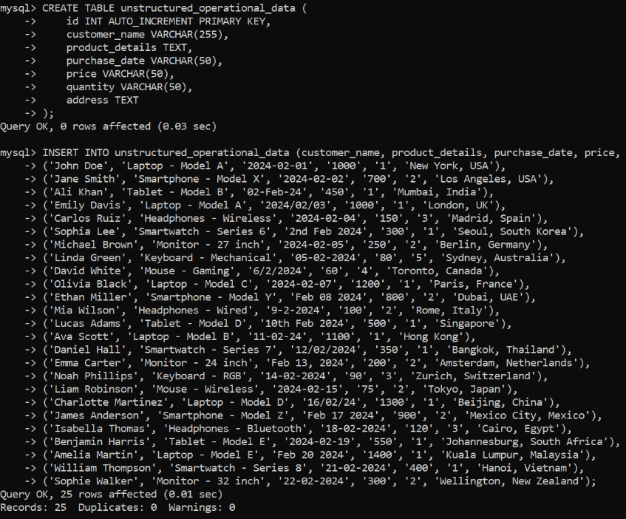

***Creating Database and Using in MySQL***

***Creating Tables***

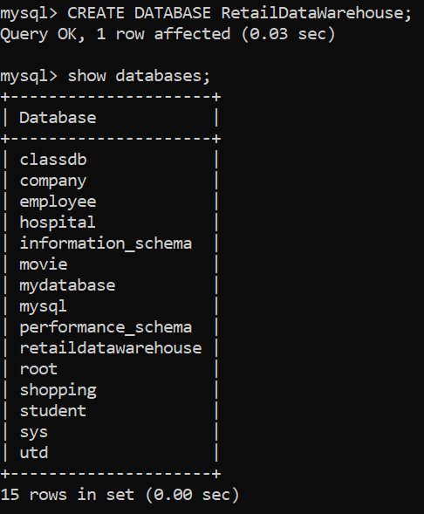

***Fig 2: Creating Tables and Inserting Data***

***Fig 1: Database in MySQL***

***Extracting and Transforming Data***

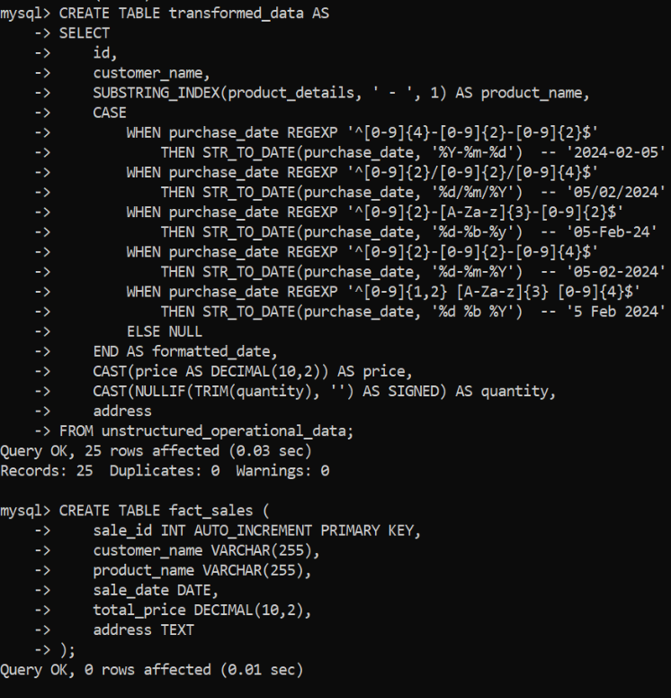

***Loading data into warehouse***

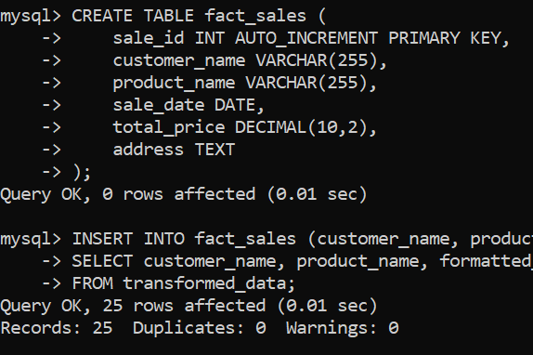

***Fig 3: Extraction and Transformation of Data***

***Fig 4: Inserting data into warehouse***